Assignment 1 - Fundamentals of Data Science

Student Name: Jatan Timilsina

Module: Fundamentals of Data Science

Assignment: Week 1 & 2 Programming Tasks

# 1. Diagram of Python Working

This diagram shows how Python works. It involves three main components: Input (user or file), Processing (Python interpreter), and Output (console or file).

User Input Python Interpreter Processing Output

Code/Input Parser + Compiler CPU/RAM + Logic Console/File

Python Virtual Machine

(PVM)

# 2. Basic Arithmetic Operations

This program takes two numbers from the user and performs various arithmetic operations like addition, subtraction, multiplication, division, modulo, and floor division.

# 3. Even or Odd Number

This program takes an integer input from the user and checks whether the number is even or odd.

Output:

# 4. Mathematical Calculations on a Number

This program takes a number input from the user and displays the square, square root, exponent (e^number), log base 10, and powers of 3, 4, and 5.

Output:

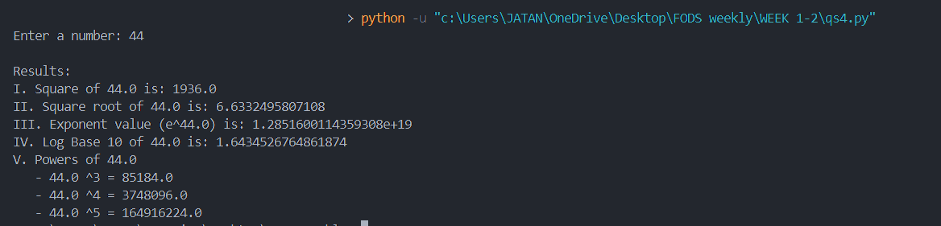

# 5. Solve Algebraic Expressions

This program solves three algebraic expressions: a² + 2ab + b², a⁵ + 2abc + b³ + c⁴, and a⁷ + 5a³b²c⁶ + b⁷ with input values for a, b, and c.

# 6. Marks and Division Calculation

This program inputs marks of 5 subjects, calculates the total, average, and percentage, and determines the division based on specified criteria.

Output:

# 7. Prime Numbers in a Range

This program takes two numbers and displays all the prime numbers between them along with the sum of those primes.

Output:

# 8. Numbers Divisible by 7 and Not Multiple of 5

This program finds all numbers between 2000 and 3200 that are divisible by 7 but not multiples of 5. A second version takes user-defined limits.

Output:

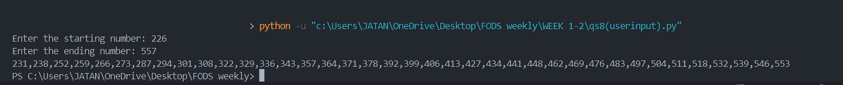

# 9. Factorial with Input Validation

This program takes input from the user and checks whether it is a number. If it is valid, it calculates and displays the factorial.

Output:

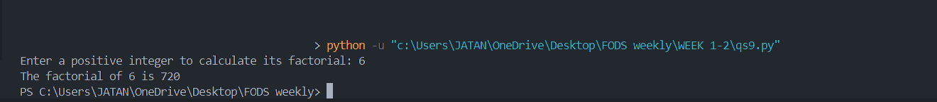

# 10. Sum of Odd and Even Numbers

This is a menu-driven program that continuously accepts numbers and keeps summing the odd and even numbers separately until the user decides to exit.

Output:

# 11. Number Guessing Game

This program generates a random number and allows the user 5 chances to guess it. Feedback is provided after each guess whether it's too high or too low.

Output:

